Wall Displays

OPTION 1

4 × 75” Professional Video Wall Panels (Ultra-Thin Bezel)

Recommended Model: Planar VM75LX-M
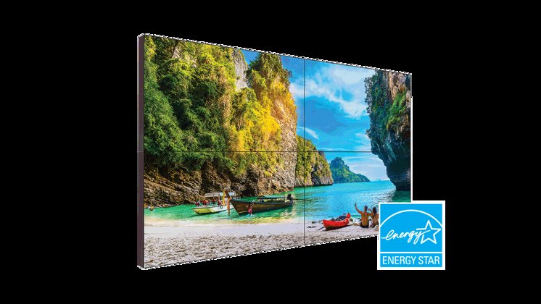
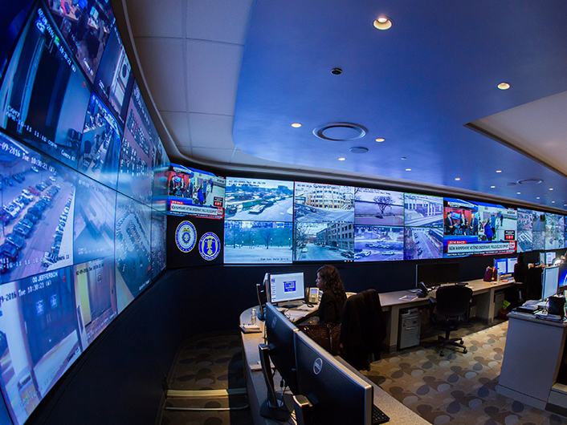
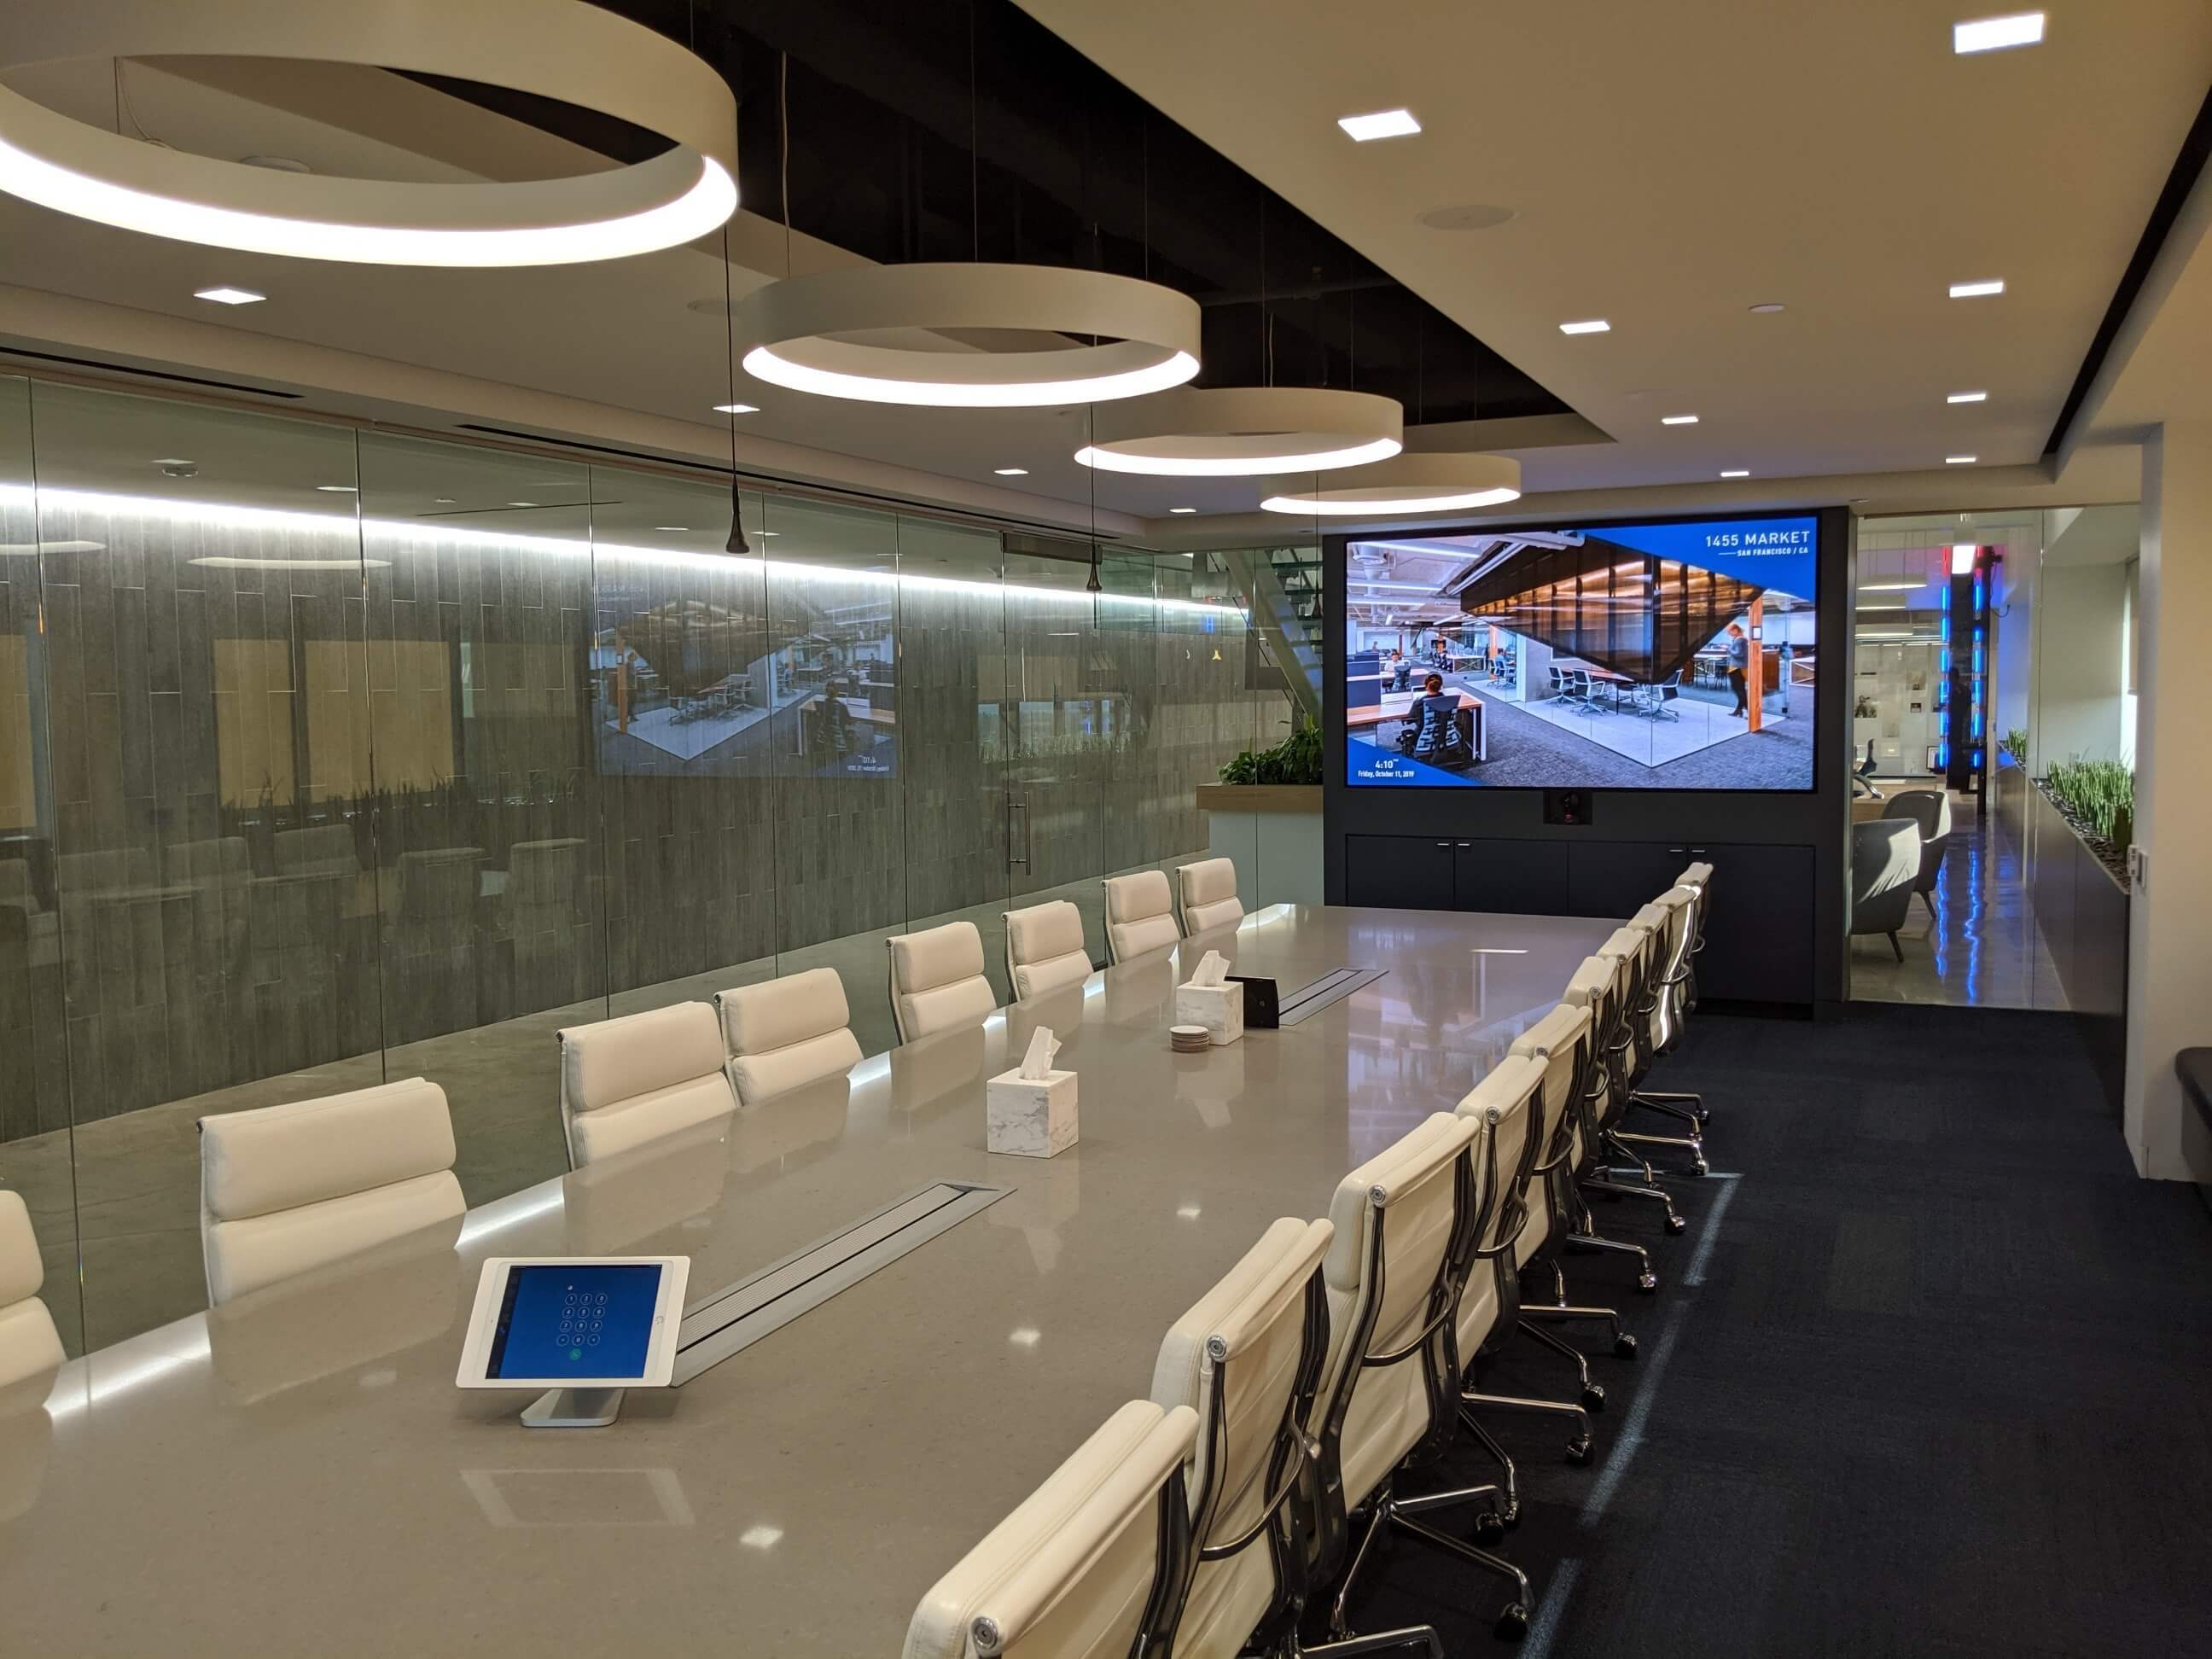
4

Display Hardware
Model: Planar VM75LX-M
Size: 75” per panel
Resolution: 3840×2160 (4K)
Brightness: 500 nits
Bezel-to-bezel gap: ~3.5 mm total
Rated for: 24/7 operation
Commercial-grade panel (not consumer TV)

Physical Size (2×2 Layout)
- Width ≈ 130 inches (~10.8 ft)
- Height ≈ 74 inches (~6.1 ft)

Pricing
Component | Price (approx)
Planar VM75LX-M (each) | $4,500
4 panels total | ~$18,000
Planar mounting system | $3,000
Installation labor | $5,000–$8,000
Display Subtotal ≈ $26k–$29k installed
Vendor sources:
- CDW
- SHI
- B&H Business
- Provantage
- Direct Planar enterprise sales

Workstation (Single Machine Driving All 4)
Recommended Build:
- CPU: AMD Threadripper PRO 7965WX (~$2,500)
- GPU: NVIDIA RTX 4090 (4x DisplayPort 1.4 outputs) (~$1,800)
- RAM: 128GB DDR5 (~$600)
- Storage: 2TB NVMe Gen4 (~$250)
- Motherboard (WRX90 platform) (~$900)
- PSU 1000W (~$250)
- Enterprise chassis (~$400)

Total Workstation:
≈ $7,000–$8,000
Vendor:
- Maingear
- Dell Precision 7865 Tower
- Lenovo ThinkStation P8
- Puget Systems

Total Cost – Planar Setup
Item | Cost
Displays + Mount + Install | ~$28,000
Workstation | ~$8,000
Cabling / signal extenders | ~$2,000
Total ≈ $38,000

OPTION 2

4 × 83–85” OLED Displays (Thinnest Bezel Possible)

Something like: LG OLED83G4 (Gallery Series) OR LG 83EP5G-B (Commercial OLED). About 8 mm bezel as opposed to about 3 mm for the Planar.
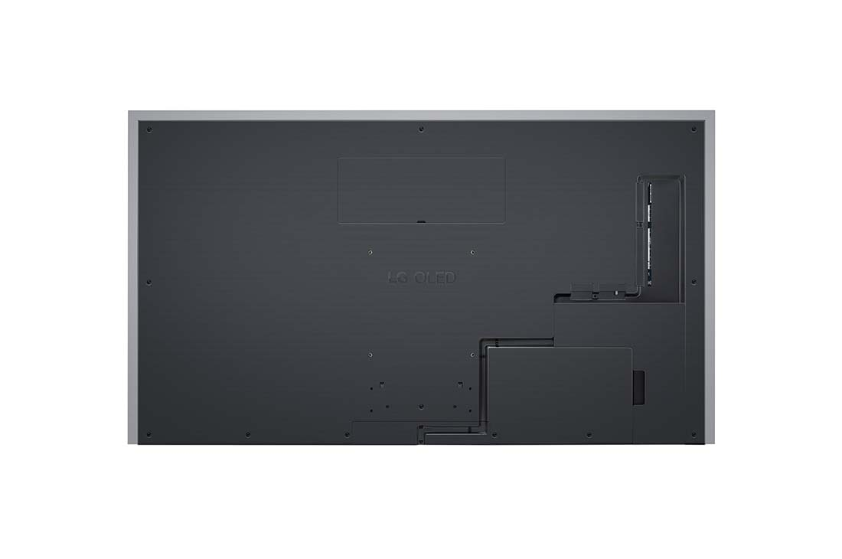

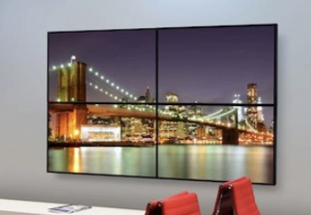
4

Display Hardware
Model: LG OLED83G4 (consumer high-end)
OR
LG 83EP5G-B (commercial OLED)
Size: 83–85”
Resolution: 4K
Contrast: Perfect black (OLED advantage)
Bezel: ~6–8 mm

Physical Size (2×2 Layout)
- Width ≈ 148 inches (~12.3 ft)
- Height ≈ 84 inches (~7 ft)

Pricing
Component | Price
LG OLED83G4 | ~$5,500 each
4 total | ~$22,000
Premium wall mount system | ~$2,500
No Installation, I can install this, or IT can install it.
Display subtotal ≈ $24,000

Workstation (Single Machine Driving 4 OLEDs)

GPU:
NVIDIA RTX 4090
- 3x DisplayPort
- 1x HDMI 2.1
For 4 HDMI 2.1 outputs:
- Use active DisplayPort → HDMI 2.1 adapters (~$150 each)
Same workstation spec as Planar Displays (~$8k).

Total Cost – OLED Setup
Item | Cost
Displays + Mount + Inst | ~$24,000
Workstation | ~$8,000
Adapters + cabling | ~$1,000
Total ≈ $33,000

Touch Table (Centerpiece)
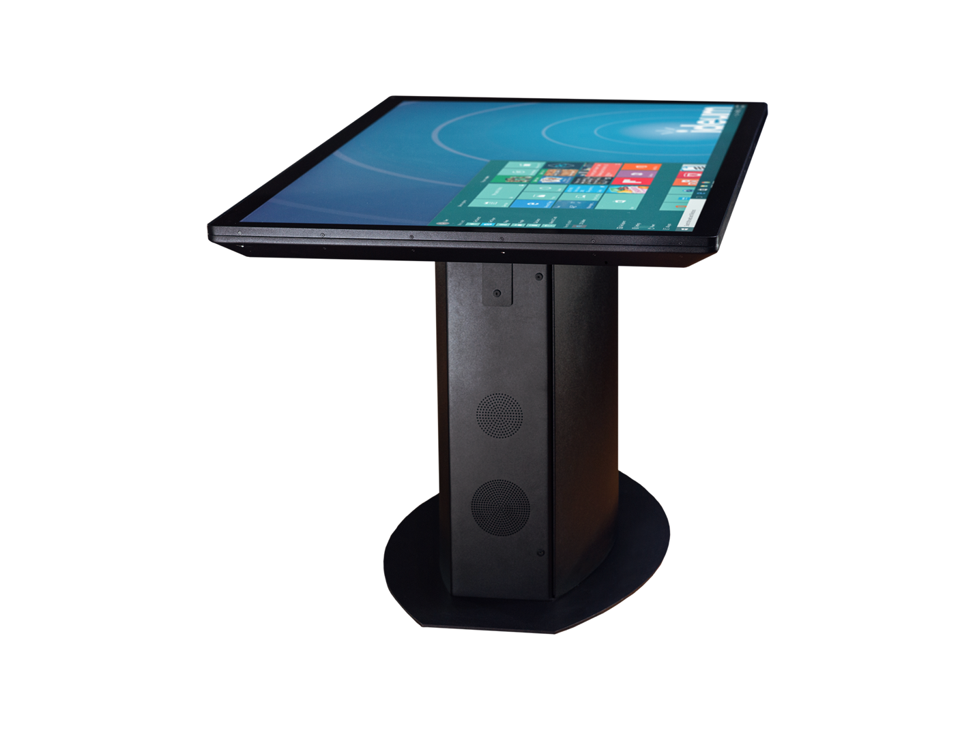Ideum 55" or 65" Multitouch Table
- 40-point touch
- 4K
- Extremely rugged
- Used in museums / NASA / military
- ~$15k–$25k
Microsoft Surface Hub 2S
- 50" or 85"
- Great collaboration
- ~$9k–$20k

Few iPads
iPad Pro 12.9” (M2 or M4)
$1,100 each

VR System
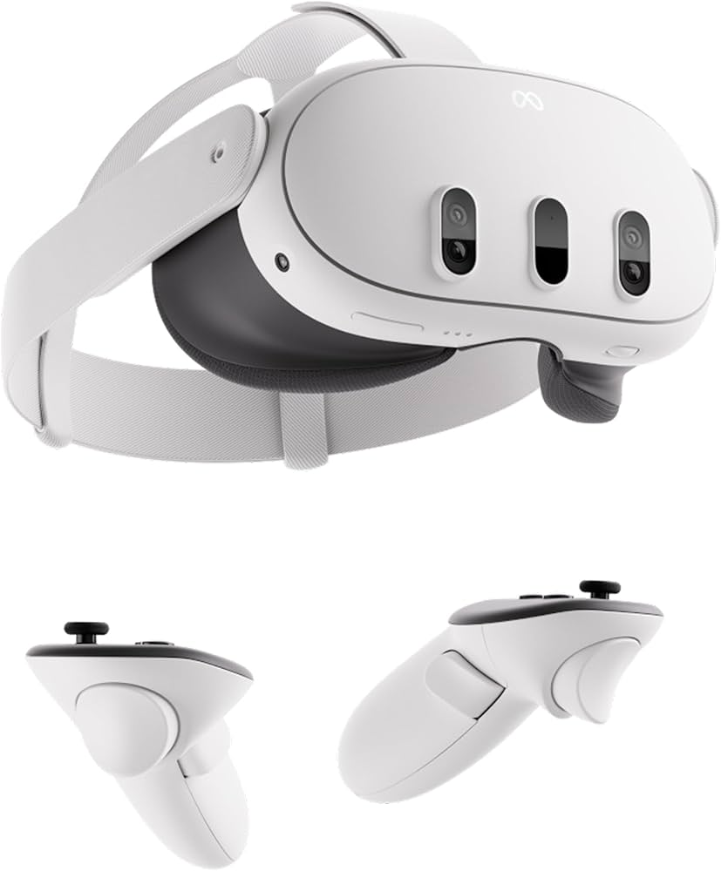


4
- Meta Quest 3 (affordable, standalone) => $500
- OR Apple Vision Pro (luxury demo impact)
- Walk inside a virtual Data Center,
- See BESS grid flow
- Observe transient stability events

AI Voice Control for wow-factor
Integrate speech interface:
- “Show N-1 contingency”
- “Simulate load ramp to 800 MW”
- “Display frequency response”

Camera Tracking
Install depth cameras (Azure Kinect or Intel RealSense) for gesture interaction.

Network Architecture
- Dedicated 10Gb internal network
- Isolated demo VLAN

